UNACADEMY FREE CAT TEST
VARC
Comprehension Passage
Directions (Q1-4): The passage below is accompanied by four questions. Based on the passage, choose the best answer for each question.
Today’s complex climate models aren’t equivalent to reality. (…) They don’t represent many aspects of the physical processes that we know are important for climate change, which means we can’t rely on them to provide detailed local predictions. This is a concern because human-induced climate change is all about our understanding of the future. (…) It helps us consider what the future will be like if we act strongly to reduce greenhouse gas emissions, if we act only half-heartedly, or if we take no action at all. Such information enables us to assess the level of investment that we believe is worthwhile as individuals, communities and nations. It enables us to balance action on climate change against other demands on our finances such as health, education, security and culture.

(…) Nowadays most of these predictions originate from complicated computer models of the climate system – so-called Earth System Models (ESMs). These models are ubiquitous in climate change science. (…) The increasing greenhouse gases in the atmosphere are driving the climate system into a never-before-seen state. That means the past cannot be a good guide to the future, and predictions based simply on historic observations can’t be reliable: the information isn’t in the observational data, so no amount of processing can extract it. Climate prediction is therefore about our understanding of the physical processes of climate, not about data-processing. And since there are so many physical processes involved – everything from the movement of heat and moisture around the atmosphere to the interaction of oceans with ice-sheets – this naturally leads to the use of computer models.

But there’s a problem: models aren’t equivalent to reality.
So, what can we do? One option is to make the models better. Make them more detailed and more complicated. That, though, raises an important question: …when will the models be good enough? (…) Some scientists argue that these models might never be sufficiently accurate to make multi-decadal, local climate predictions. Nevertheless, changing the way we use ESMs could provide a different and better way to generate the local climate information we seek. Doing so involves embracing uncertainty as a key part of our knowledge about climate change. (…)

ESMs are fantastic achievements of modern computer-based science and tremendously useful tools for research. (…) However, just because they’re great research tools doesn’t mean they’re reliable engines of prediction. To be useful research tools, they need only represent some key characteristics of the processes we’re studying. But to provide reliable, multi-decadal predictions of the local consequences of climate change, they need to represent all the diverse interacting processes that we think could be important on climate change timescales. And they need to do this in a realistic fashion. They need to represent what we actually think is going on.

(…) Furthermore, today’s Earth System Models are not ‘close to reality’. (…) When we use these models to simulate the past, their outputs are far from being consistent with what happened in the real world. (…) This has led to a dissonance in the climate research community. (…) There is no significant disagreement in the climate research community that the models have significant flaws. Where there is disagreement is on what we should do about it: on how we can get better information about the future of Earth’s climate.
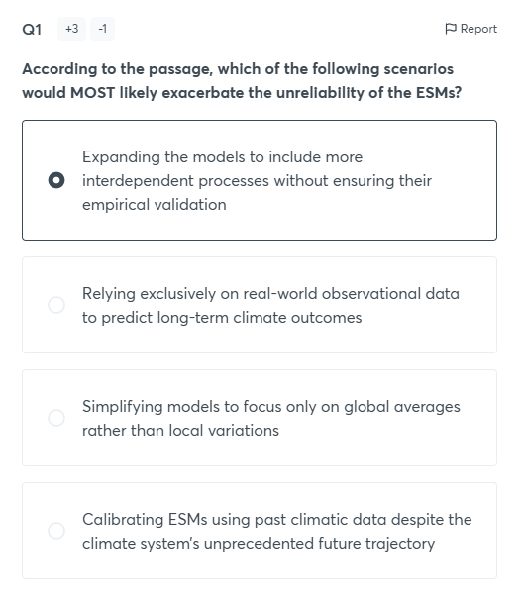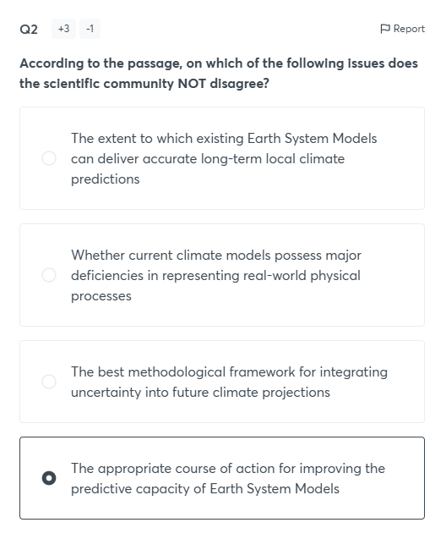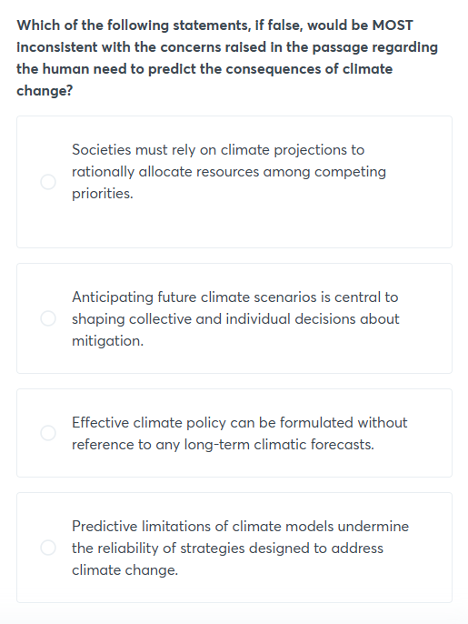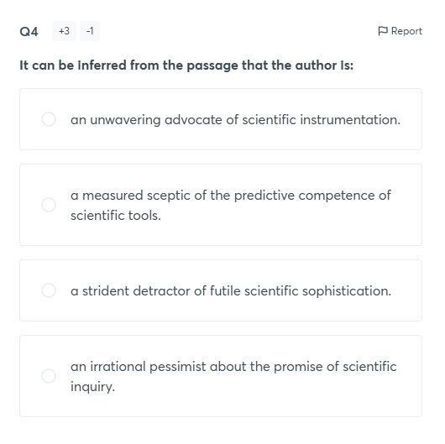Comprehension Passage
Directions (Q5-8): The passage below is accompanied by four questions. Based on the passage, choose the best answer for each question.
One Enlightenment aspiration that the science-fiction industry has long taken for granted, as a necessary intergalactic conceit, is the universal translator. Remember Spock and Kirk’s machine that translated The Companion in ‘Star Trek’? (…)

The exchange (between them) emphasizes the utopian ambition that has long motivated universal translation. The Companion might be an alien (…) but once Kirk has established communication, the first thing he does is teach her to understand love. It is a dream that harks back to Genesis, of a common tongue that perfectly maps thought to world. In Scripture, this allowed for a humanity so well coordinated, so alike in its understanding, that all the world’s subcontractors could agree on a time to build a tower to the heavens. Since Babel, though, even the smallest construction projects are plagued by terrible delays.

Translation is possible, and yet we are still bedevilled by conflict. This fallen state of affairs is often attributed to the translators, who must not be doing a properly faithful job. (…)

Translation promises unity but entails betrayal. In his wonderful survey of the history and practice of translation, “Is That a Fish in Your Ear?” the translator David Bellos explains that the very idea of “infidelity” has roots in the Ottoman Empire. The sultans and the members of their court refused to learn the languages of the infidels, so the task of expediting communication with Europe devolved upon a hereditary caste of translators, the Phanariots. They were Greeks with Venetian citizenship residing in Istanbul. European diplomats never liked working with them, because their loyalty was not to the intent of the foreign original but to the sultan’s preference. Ottoman Turkish apparently had no idiom about not killing the messenger, so their work was a matter of life or death. We retain this lingering association of translation with treachery.

The empire of English has a new Phanariot class, and they are inventing the chrome light-sabre apps of the utopian near-future. They are native speakers of C++, and they reside in our midst on semipermanent loan from the Internet. On the plus side, they are faithful to no sultan. The minus is that they are not particularly loyal to any language at all.

Google Translate is far and away the venture that has done the most to realize the old science-fiction dream of serene, unrippled exchange. The search giant has made ubiquitous those little buttons, in email and on websites, that deliver instantaneous conversion between language pairs. Google says the service is used more than a billion times a day worldwide, by more than 500 million people a month. (…)

(…) Many computational linguists continue to claim that, after all, they are interested only in “the gist” and that their duty is to find inexpensive and fast ways of trucking the gist across languages. But they have effectively arrogated to themselves the power to draw a bright line where “the gist” ends and “style” begins. (…) The problem is that all texts have some purpose in mind, and what a good human translator does is pay attention to how the means serve the end — how the “style” exists in relationship to “the gist.” The oddity is that belief in the existence of an isolated “gist” often obscures the interests at the heart of translation.
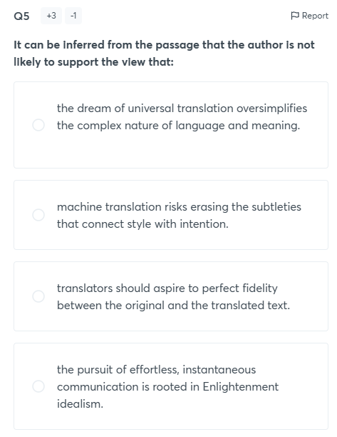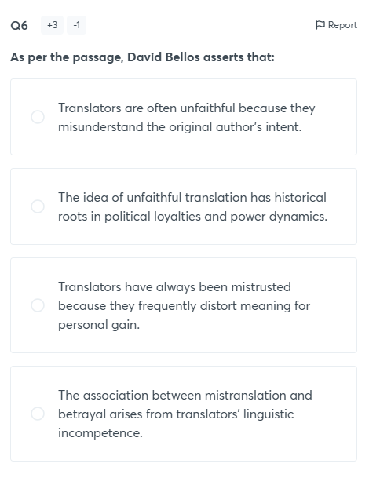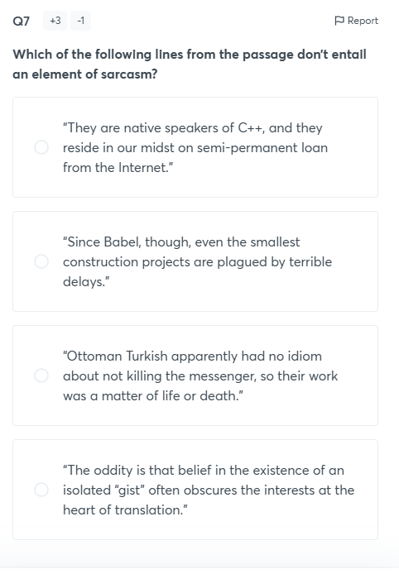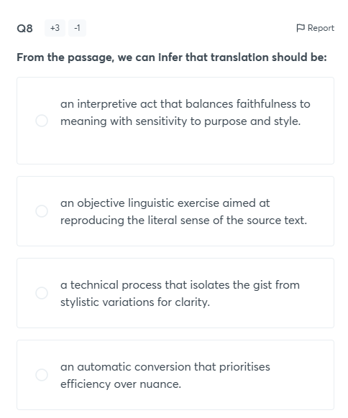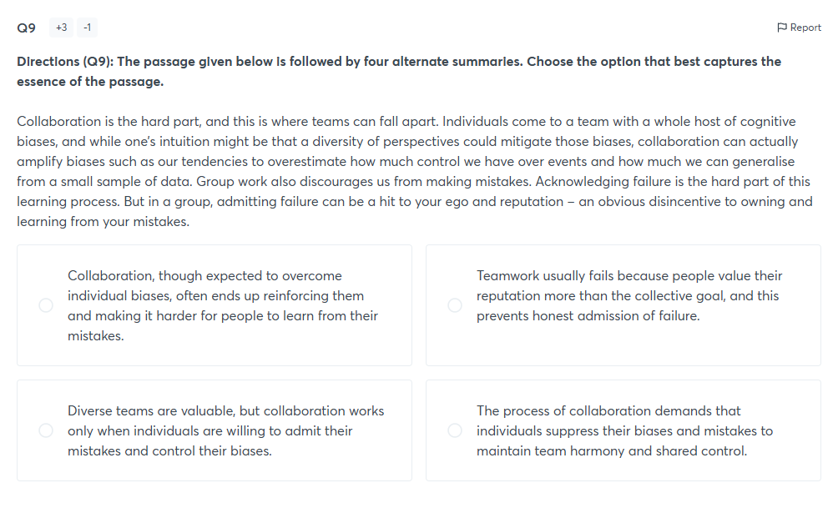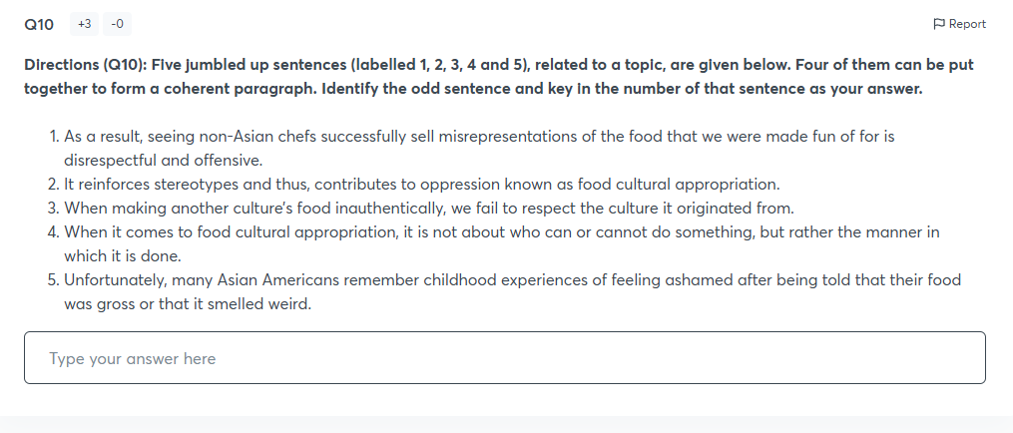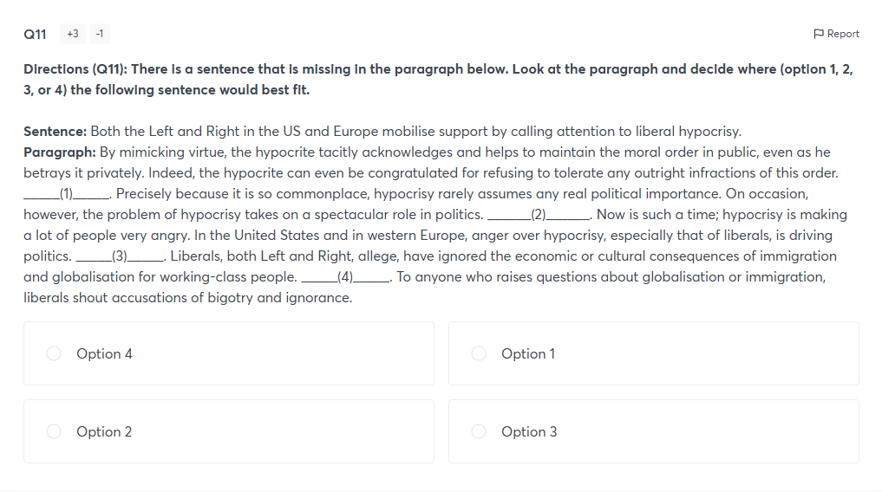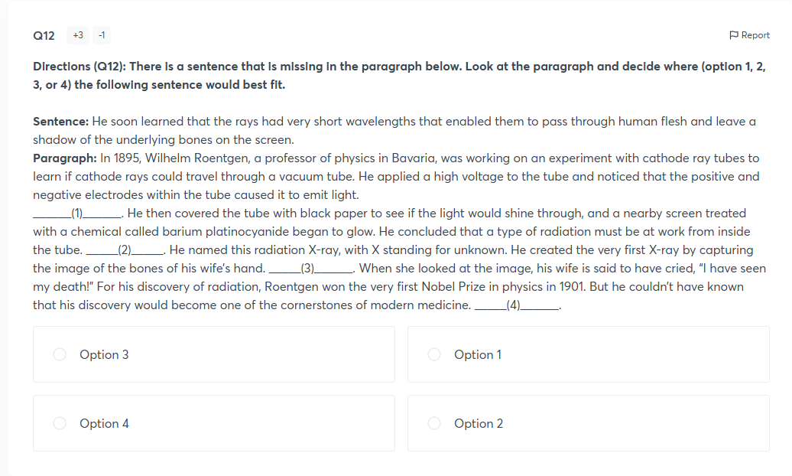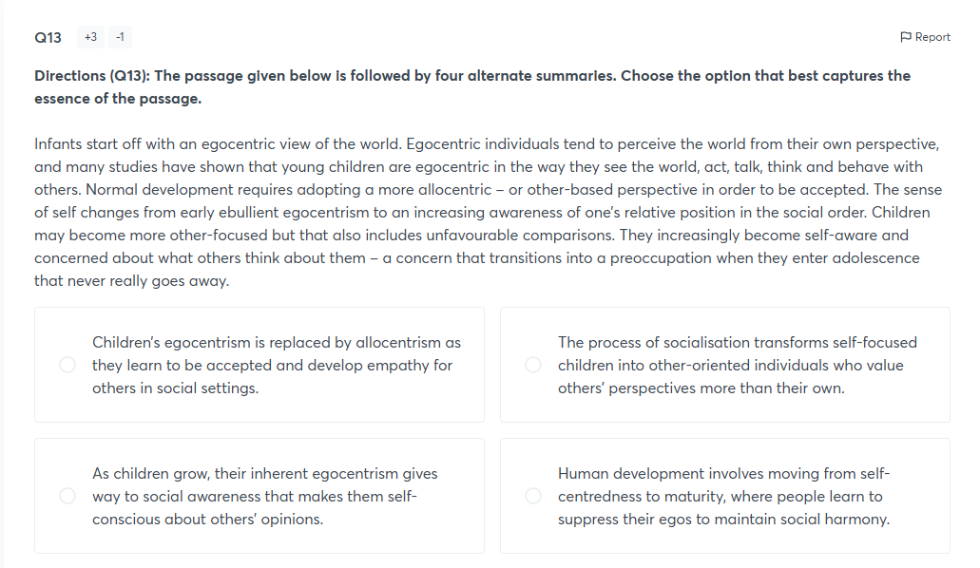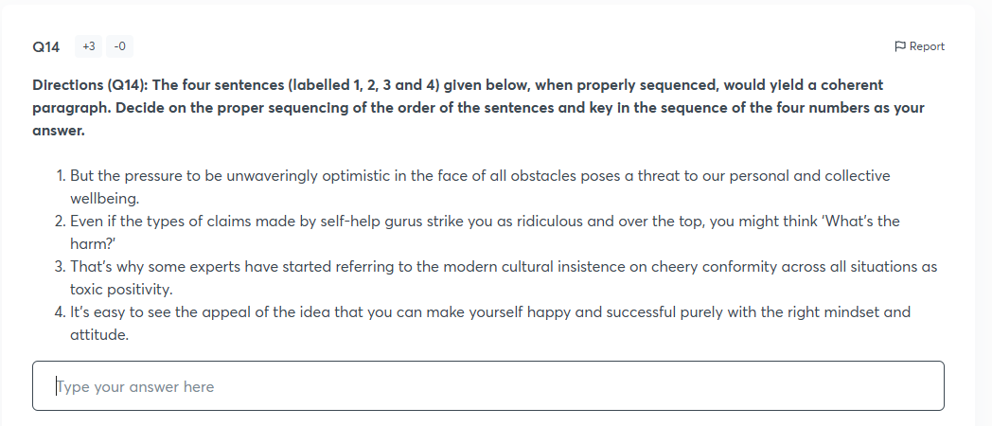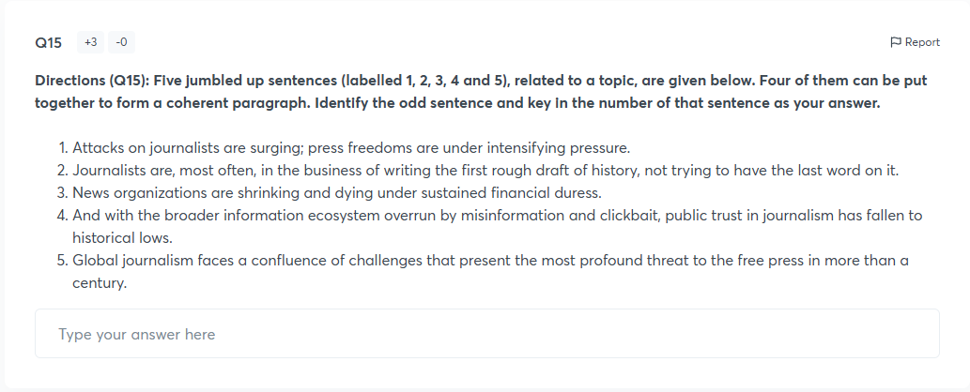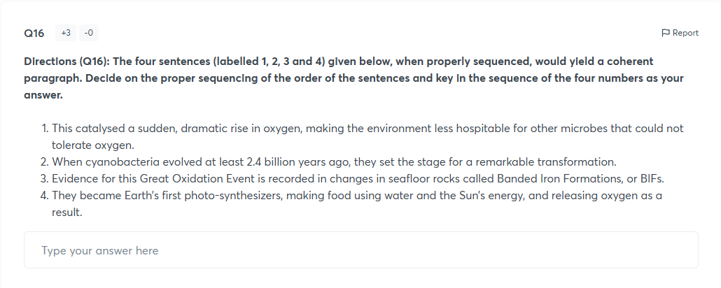Comprehension Passage
Directions (Q17-20): The passage below is accompanied by four questions. Based on the passage, choose the best answer for each question.

(…) (You) can stop feeling guilty for procrastinating. Science has come up with a defence of your condition.

Researchers have independently identified the phenomenon of positive procrastination, although there’s some disagreement on what to call it. “Structured procrastination” is the preferred term of John Perry, a philosopher at Stanford. (…)

Dr. Perry was a typical self-hating procrastinator until he realized, (…) “procrastinators seldom do absolutely nothing.” A modest insight, perhaps, but it eased his conscience and disabused him of the old idea that procrastinators should limit commitments. The key to productivity, he argues (…) is to make more commitments — but to be methodical about it. Indeed, (with the correct strategy,) the procrastinator can even acquire a reputation for getting a lot done. (…) The psychological principle is this: anyone can do any amount of work, provided it isn’t the work he is supposed to be doing at that moment. (…)

Perry attributes the finding about an increase in the tendency to procrastinate among today’s workers to the changing nature of the workplace: the more flexible that jobs become, the more opportunities to avoid unpleasant tasks. Workers now typically spend a quarter of the day procrastinating, students a third of the day. Men are more likely than women to be chronic procrastinators, especially young men.

(…) For now many self-control researchers have doubts about positive procrastination. Even when it works, they say, you’re still wasting energy as you fret, consciously or unconsciously, about the task you’re avoiding.

Dr. Perry says it often makes sense to follow that classic advice for procrastinators: Just get started. He knows his strategy is tricky. Structured procrastination requires a certain amount of self-deception, because one is in effect constantly perpetrating a pyramid scheme on oneself. One needs to be able to recognize and commit oneself to tasks with inflated importance and unreal deadlines while making oneself feel that these tasks are important and urgent.

Fortunately, he notes, procrastinators can be great at self-deception. Productive procrastination is a bit of make-believe, along the lines of setting your watch five minutes fast. You know you did it, but you still pretend you didn’t. Not everyone can do this. It works best for those who feel guilt for their procrastination and need to assuage it. If you are among the set of people who cleaned their dorm room the night before exams, it likely will work.
﻿
At the very least, you can use it to stop feeling so bad about a problem that everyone shares. It’s certainly a saner strategy than the bromide about never putting off until tomorrow what you can do today. By that logic, you’d never stop working — there’s always something that could be done today. Better to follow Dr. Perry’s rewritten version: Never do today any task that may disappear by tomorrow.
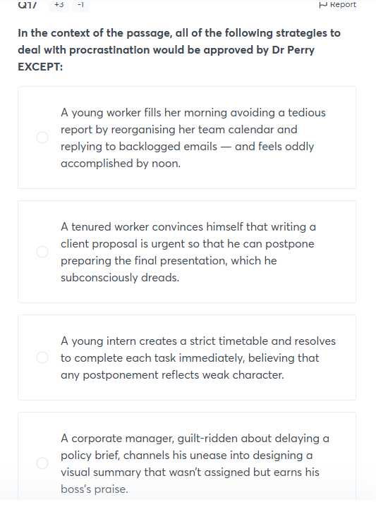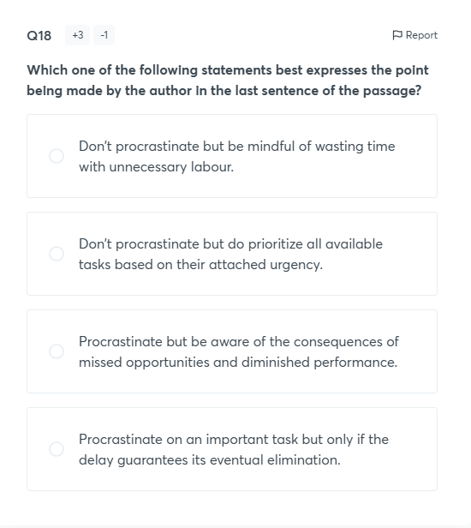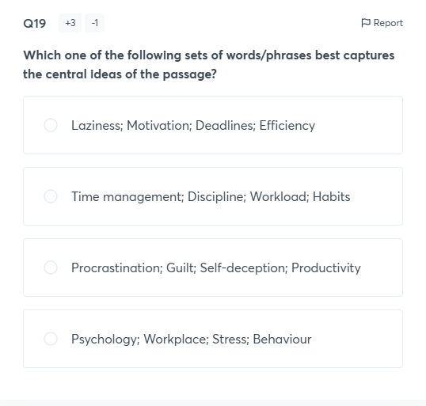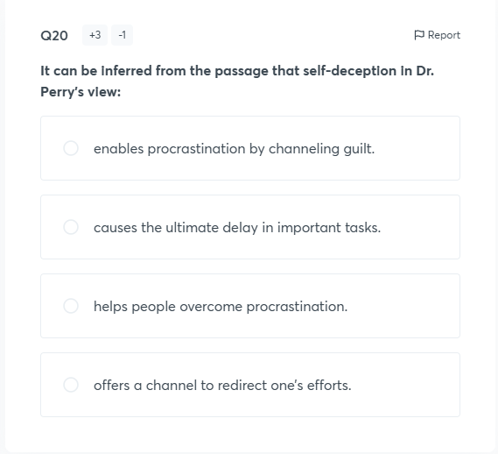Comprehension Passage
Directions (Q21-24): The passage below is accompanied by four questions. Based on the passage, choose the best answer for each question.

(…) Science is in deep trouble. While modern research remains wondrously productive, its results are more ambiguous, contestable and dubious than ever before. This problem isn’t caused by a lack of funding or of scientific rigour. Rather, (…) we need to let go of a longstanding and cherished cultural belief – that science consists of uniquely objective knowledge that can put an end to political controversies. Science can inform our thinking; but there is no escaping politics.

(…) (But, we must) note the corollary to (this) argument: that a change in our expectations concerning the use of science for policy implies the need to make something like philosophical deliberation more central to decision making.

(Is) Philosophy relevant? We had better hope so. Because the alternative is value fundamentalism, where rather than offering reasons for our values, we resort to dogmatically asserting them, … a prescription for political dysfunction. (…) (We must) employ individuals with philosophical training in a wide variety of policy and regulatory institutions: not as specialists whose job is to provide answers, but to ask the right kinds of questions.

As it is currently constituted, academic philosophy is not up to this task. A premium is placed on theoretical rigor, at the loss of social significance.(…) Prior to the twentieth century, philosophers could be found in a variety of occupations. Since 1900, however, they have had only one home – (university departments) which ghettoize ideas, steering philosophers toward problems of interest to their disciplinary colleagues – at the cost of practical relevance to wider societal concerns. (…)

Philosophers have mimicked scientists in all the worst ways: practicing a highly specialised discipline and speaking primarily to one another. (…) This suggests the need for something analogous to … “trans-science”, a problem-oriented approach to inquiry that is judged by its success in the real world, rather than by disciplinary metrics. (It) begins with an act of “selfless honesty” where experts acknowledge that an issue has exceeded the boundaries of their domain.

Trans-scientists have to know when they don’t know – otherwise they’ll labour under the illusion (and perhaps fool others too) that they are capable of solving problems that they can’t. This is the stuff of Socrates (for whom) wisdom consisted in knowing that one doesn’t know. He exposed the self-assured expert as a poseur, pronouncing on matters outside his jurisdiction.

If trans-science is our new ideal, then Socrates is back in business. Philosophers working within the Socratic model can bring useful skills to our knotty problems, including hermeneutics (thinking through issues that allow varying interpretations and framings), ethics (uncovering and analysing hidden value commitments), and epistemology (assessing different claims to knowledge).

But as important as these activities are, more crucial is the propagation of a distinctive mindset: a commitment to explaining one’s values and to giving a hearing to the values of others. This will require philosophers to also let go of their cherished claims to expertise, and engage in humble collaborations with others. Above all, they need to stop talking only to one another. (…)
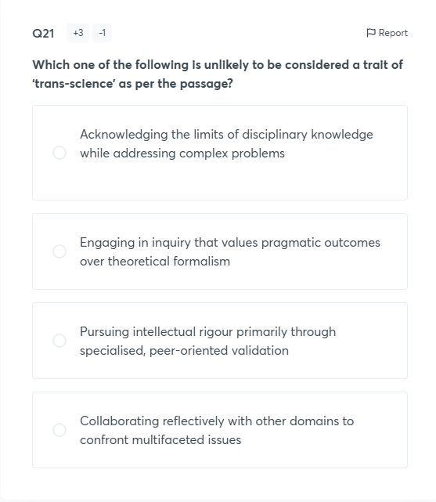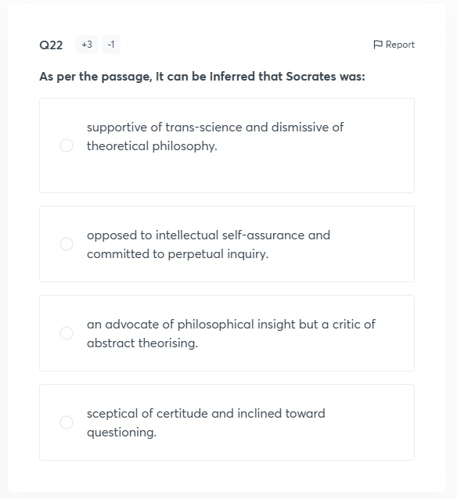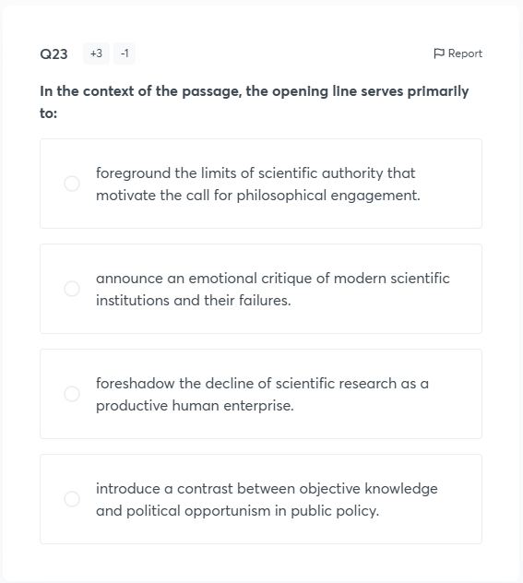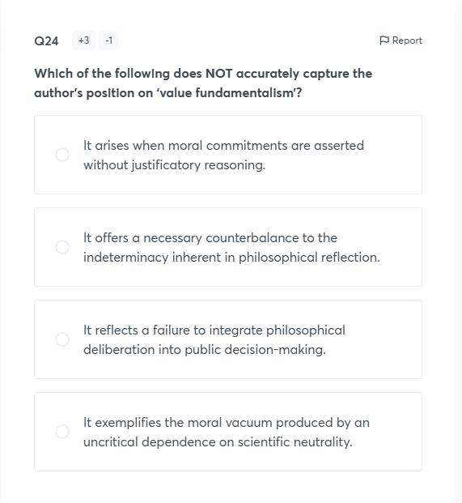

DILR
Comprehension Passage
Directions for questions 1 to 4:

The 'Global Football Super League 2025' was organized with 30 top clubs from around the world participating. One club represented each region/country. A Club was judged in three categories: Home Points, Away Points, and Fair Play points. The following table shows the points and the rankings of the clubs from twelve regions out of 30 in these three categories.
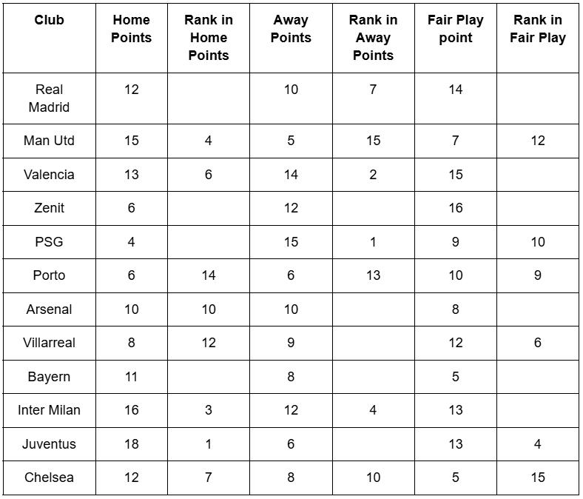
If two clubs got an equal number of points in any category, then they were given the same ranking, and the next ranking was skipped. If three clubs got an equal number of points in any category, then they were given the same ranking, and the following two rankings were skipped. On similar lines, rankings were decided.
For example:
If a team got a score of 15 and a rank of 5, and another club also got a score of 15 then its rank will be 5, and the team whose score is 14 will have a rank of 7, and so on.

[NOTE: All the remaining 18 clubs (the ones that are not mentioned in the above table) scored a unique points in any category, and all the questions below are based on the twelve teams mentioned above]
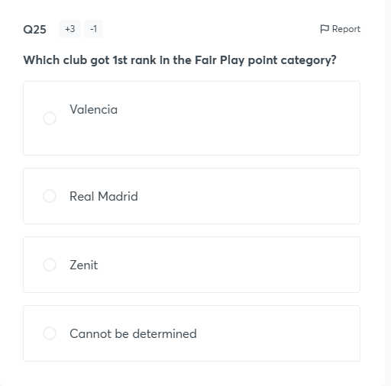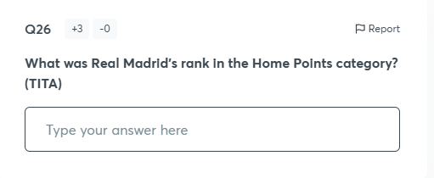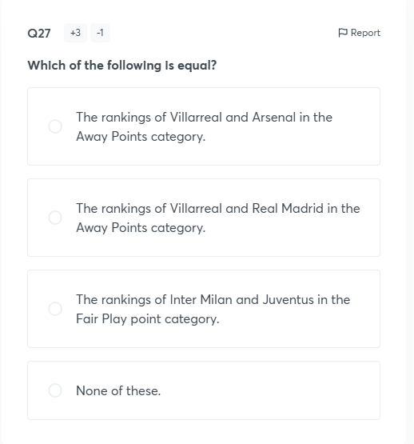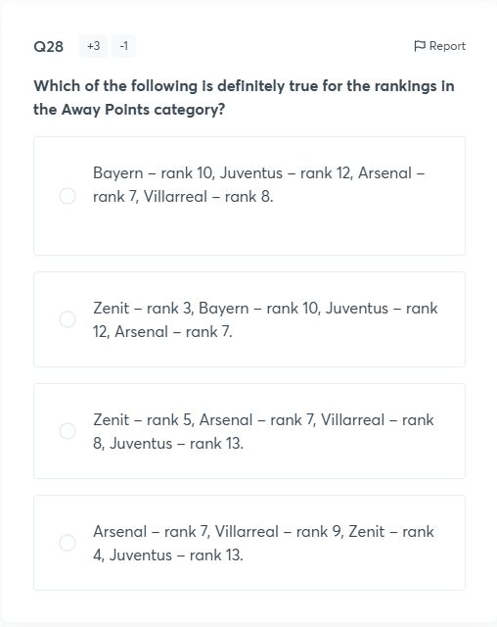Comprehension Passage
Directions for questions 5 to 9:

Each of the three logistics agents, Anya, Bryan, and Carlos, manages goods distribution for a warehouse. Every day, each of them logs a positive integral number of Packages Handled (PHs) during three particular shifts: Morning, Afternoon, and Evening. The details about the number of PHs logged by each of them over three particular shifts are given below.
- In the Evening shift, Bryan handled twice the number of PHs that Carlos handled, who handled the same number of PHs as Anya.
- In the Afternoon shift, both Anya and Carlos handled an equal number of PHs, which was equal to 3/4th of the number of PHs handled by Bryan.
- The number of PHs handled by Bryan in the Morning shift is one more than the number of PHs handled by Anya in the Afternoon shift, which is one more than the number of PHs handled by Carlos in the Evening shift.
- The number of PHs handled by Anya in the Morning shift is one more than the number of PHs handled by Carlos in the Afternoon shift.
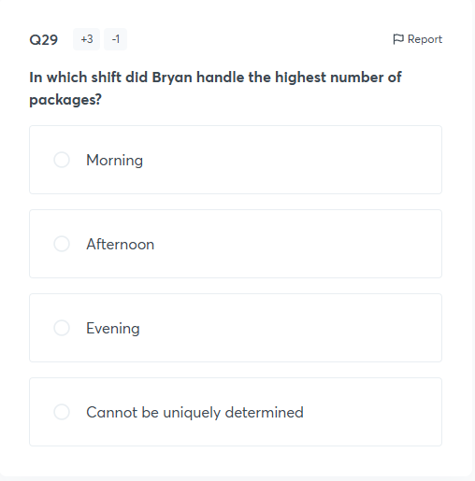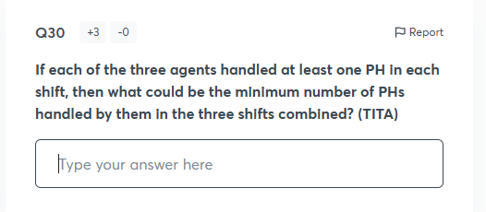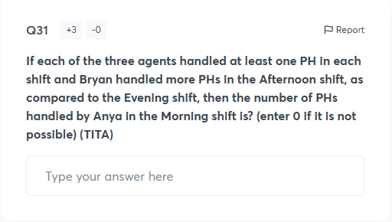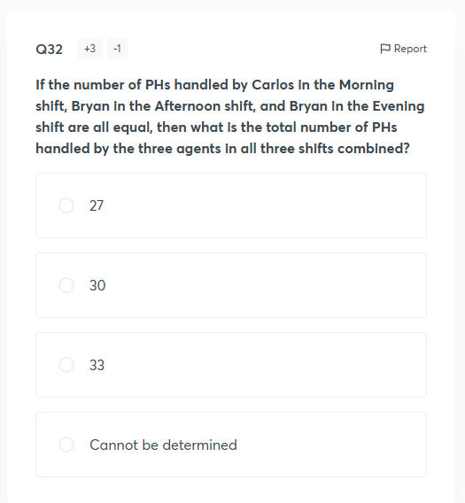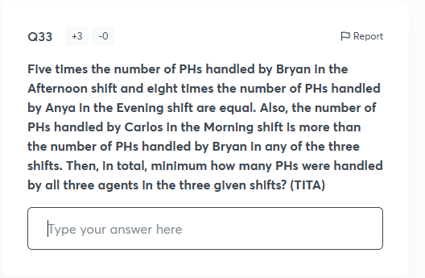Comprehension Passage
Directions for questions 10 to 13:

"Global E-sports League (GEL)" is a leading e-sports organization. It assigns a score (out of 5) to various teams on each of the following four parameters: Mechanics (M), Strategy (B), Teamwork (F), and Clutch Factor (C). The overall tournament score assigned to a team is the weighted sum of the points scored in the four parameters. The "Difficulty Multipliers" (weights) for the four parameters are 5, 10, 15, and 20 in some order.
The following table shows the scores assigned by GEL to eight different teams (P, Q, R, S, T, U, V, and W) on each of the four parameters:
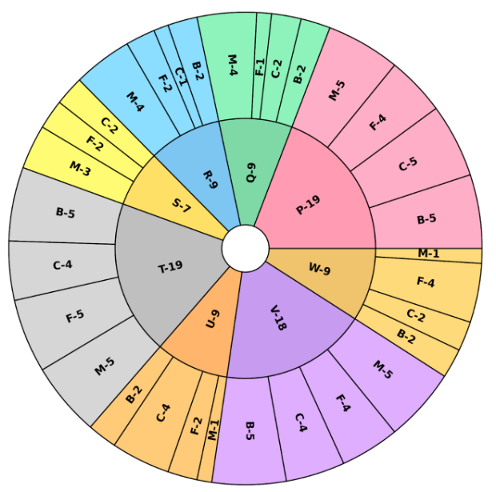
Additionally, the following points are known:
The overall tournament score of team P is higher than that of team T. The overall score of team W is higher than that of team Q. The difference between the maximum overall score and the minimum overall score for these eight teams is 165.
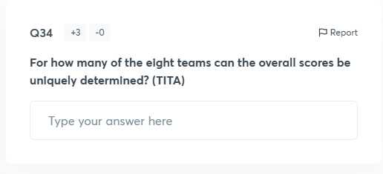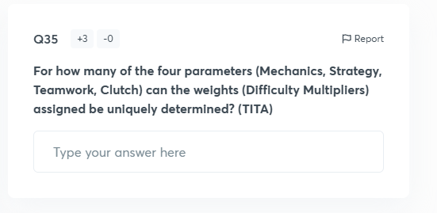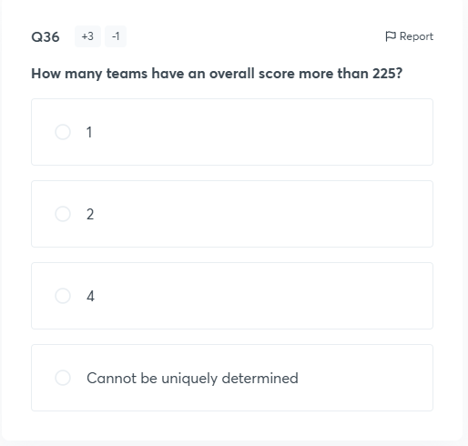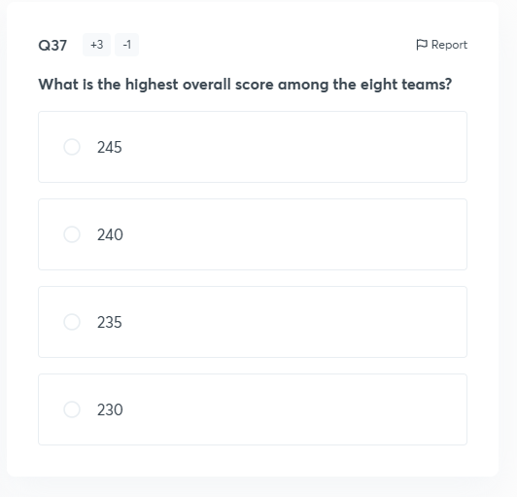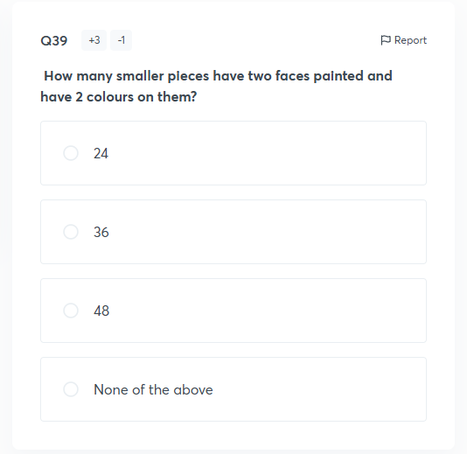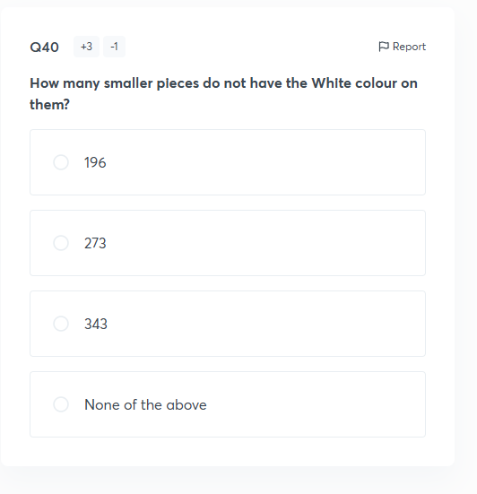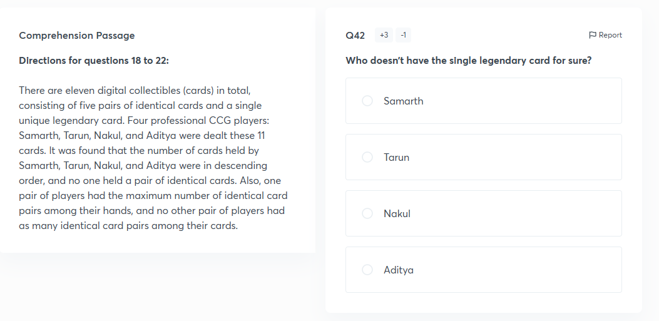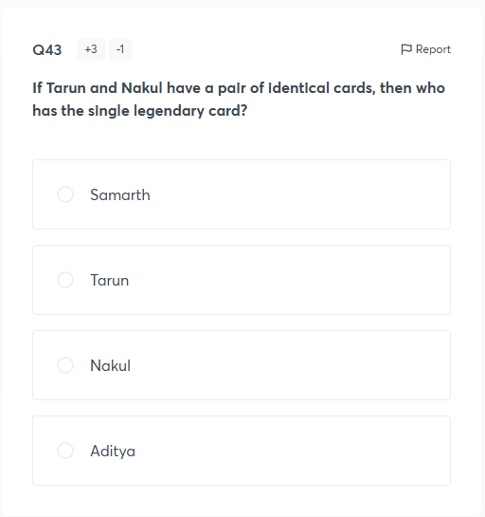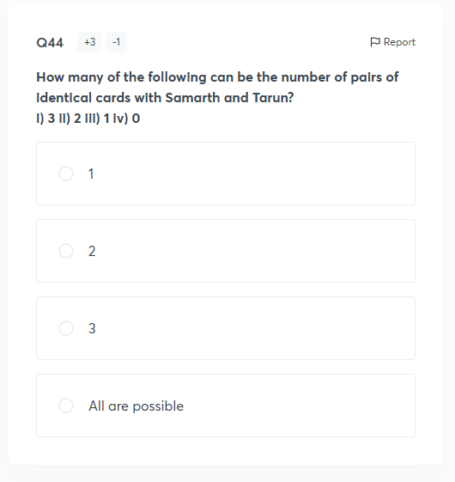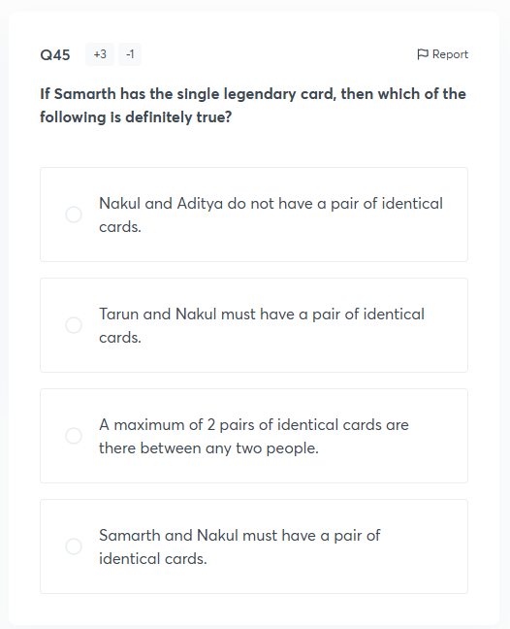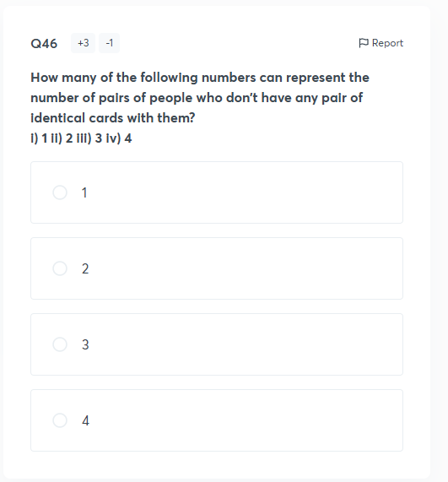

QUANTS
